GEROGERY HORSEMAN’S
Newsletter
February 2014

Committee for 2014 is
President Sue Everitt, 0427294266
Secretary Katrina McMaster, 0412826440

Treasurer Thea Howell, 0412213752

Rally and Event Organiser Katrina McMaster, 0412826440
kjmcmaster1@hotmail.com

Newsletter Lindy Wishart
l.wish01@bigpond.com

Website Manager Rebecca Fraser-Goring
From the Editor
It is great to welcome back everyone to 2014. I think it is shaping up to be an amazing and very busy year for Gerogery Horseman’s. Check out the news for our grounds further on in the newsletter. Very exciting!

Rallies and clinics are starting, even though we are in the middle of the second heatwave this year. Hoping that you are all finding ways of keeping cool. Don’t forget our four legged friends in this heat, give them some extra love.
Keep cool and riding
Lindy
When paying for clinics please pay through the Hume Building Society.
Phone Katrina to confirm your place.

Details of the bank are:
Hume Building Society
BSB 640-000 ACCT 561544516
Reference Your name.

Email
gerogeryhorsemansinc@hotmail.com

Snail Mail
C/- Gerogery General Store
Gerogery 2642

Triple T report and photos by Katherine Noske
TTT Showing was held at Tatura in Victoria on the 14th and 15th of December 2013. We were pleasantly surprised at the great facilities and truly lucky with the weather, one week later and we would have been baked to a crisp! The teams were: The Purple Invaders-Sue, Steph and myself (Katherine) and the Purple Haze-Melissa, Thea and Rebecca. Everyone except Melissa competed Saturday, who kindly arrived earlier than planned Saturday to volunteer, after the planned volunteer had to change plans.
Steph, Rebecca and I all competed in the same ring (different height divisions) while Sue competed in level one and Thea in level three. Melissa competed in level one on Sunday.
Both Steph and myself came second in our respective rider classes, I came second in ridden exhibit, fourth MMS and first in pleasure mount! Thea received two thirds, a great result in a high-quality ring, Rebecca came 5th in her SOP and Melissa was 9th in the Highpoint for her ring. Sue also competed well, coming equal fifth in the Highpoint for her ring.
Thankyou to everyone who helped out, especially Kellie Noske and Melissa Chaston for fulfilling our volunteer duties and Katrina and Thea for your organization skills. A great time was had by all and we await the host for next year. 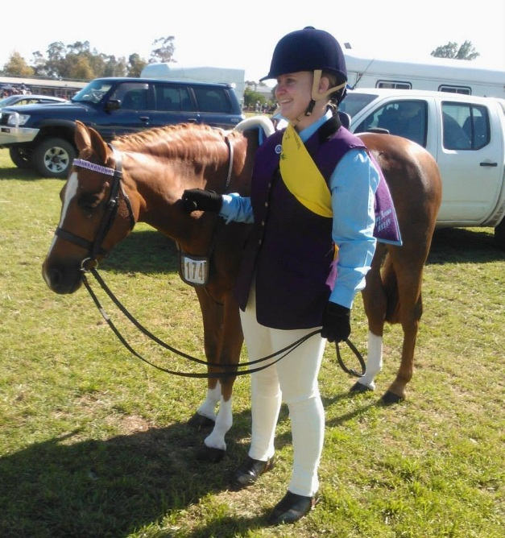 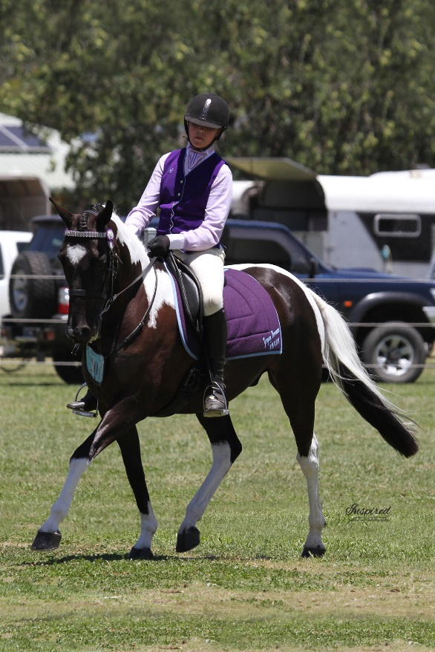
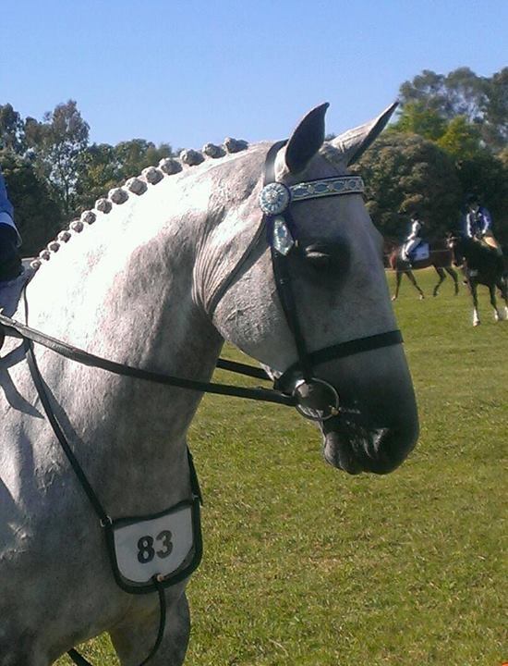
Above, Bec and Jewel.
Top Right Stephanie and Bristol.
Right, Ella.

ARC Show Jumping Indigo. Report and photos by Katherine Noske
Our Australia Day was celebrated at Chiltern, competing in the Indigo ARC show jumping day. Myself, Steph and Kay Harding attended. Steph competed level three and won her AM7, however pulled a rail in the two phase round which put her out of the placing’s for that event. Kay's round was going beautifully until her horse stumbled. Thankfully, they are both okay. I was placed seventh in both my events, but I thought Reggie jumped better than that, but maybe I am a little biased.
Overall, it was an enjoyable day, in a lovely spot (except for the trains!) and with nice weather, so it was a great way to spend Australia Day!

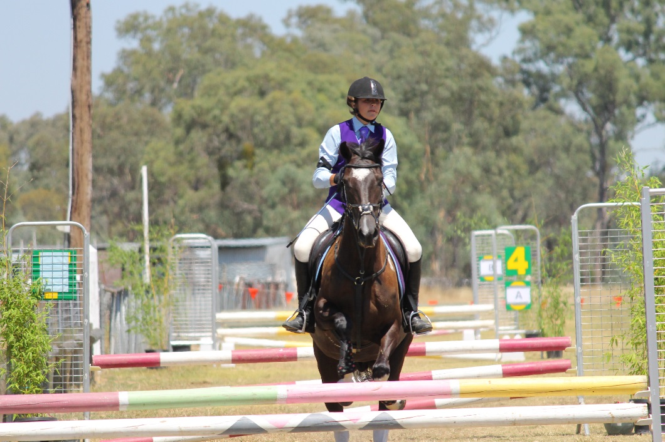
Stephanie and Bristol.

29th March Wodonga Ag Show
Vine Valley are running the Adult Riding Ring. Please support them. We know how much work goes in behind the scenes and if riders don’t support these events they will end up not happening. We have enjoyed fantastic support at our events and this time we can support another local club. So mark this in your diaries and get entries in.

8th Feb Henty Ag Show.
After the success we have had running the Adult Riding Rings at the Culcairn and Walbundrie Ag Shows we were approached to run the Adult Riding ring at the Henty show.
Attached is the program for you to consider.

Gerogery Home Grounds.
Boundary fences have gone up.
On Saturday, 18th a small but enthusiastic band of members and family braved the heat and started clearing up the grounds. About 8 trailer loads of weed were removed from the arena. The remaining area has been sprayed and will be removed when they have died off.
The Culcairn Council are giving us a load of sand to help improve our arena. It seems like removing the trees has been such a lengthy process but we can see the end in sight. It will be great for this area to be up and running for our members to be use at any time. The arena will be locked and we are currently discussing options about keys, and issuing them to users. It needs to remain locked so the general public doesn’t have access as there can be insurance consequences. Any suggestions will be considered.
More exciting news is that the toilet block in Gerogery, near shop, is being re located and will be placed near the arena. This will be great and adds to the usefulness of our area. The toilets at the tennis club end have finally been repaired so in the meantime they are there for our use.
I have saved the most exciting news to last. We, Gerogery Horseman’s, have formed a friendship with Upper Murray Horseman’s Association. This will complement what we do with our focus on Dressage and Jumping. They will offer many different events including Team Penning and 2 Handed Culling. Come along and see what they can do. UMHA will also be having a working b at our arena over Easter. They plan to have their first event on the 3rd and 4th of May and expect riders to travel form Melbourne and Echuca. For more info contact Ronnie (Sid) Wilson 0427718640.

Club Apparel
NEWS FLASH club woollen jumpers’ orders being taken now
An update on the jumpers! Unfortunately we need 15 members wanting a jumper to place an order and as of yet we are not there. So if you want a jumper please contact Thea to place your order. The jumpers will be $65.00 and will need to be paid for when ordered.

Any interest in a vest?

Longer line vest with piping: $55
Matching stocks: $22
Baseball caps with club logo: $20
Club polo’s: $35
Saddle blankets: $40
Club badges (pins): $5
Woollen Saddle Cloths $65

Expressions of Interest for TTT
I am hoping that we might be able to put together at least 1 team for both the TTT Combined Training and Horse Trials. The Combined Training is to be held at Bulla on the 15th & 16th March 2014' entries close 21st February 2014, and the Horse Trials are at Yarrambat on the 17th & 18th May, no closure date as of yet. I know that both events are a few months away yet but would like to get names of people interested now so I can have an idea of who is keen and if we have enough for a team. Both locations are down near Melbourne so a little travelling involved but I believe the experience will be well worth it.
Anyone interested can contact me Kellie Chivell on 0419172312, email me at
kelliechivell@yahoo.com.au

http://www.hrcav.com.au/site/hrca/vic/downloads/Programs/2014%2520TTT%2520combined%2520training%2520.pdf

The wind of heaven is that which blows between a horse's ears.
- Arabian Proverb

