** **

**GEROGERY HORSEMAN’S**

**Newsletter**

**APRIL 2014**

President Sue Everitt, 0427294266

Secretary Katrina McMaster, 0412826440

Treasurer Thea Howell, 0412213752

Rally and Event Organiser Katrina McMaster, 0412826440

[kjmcmaster1**@hotmail.com**](mailto:kjmcmaster1@hotmail.com)

Newsletter Lindy Wishart

[l.wish01@bigpond.com](mailto:l.wish01@bigpond.com)

 Website Manager Rebecca Fraser-Goring

**From the Editor**

It’s hard to believe it is already Easter bunny season. Gerogery Horseman’s have had members out and about at events through February and March.

What I need is for our members that compete at events to supply me or another committee member with a brief report and any photos that they take. I have found that if I contact members they are more than happy to contribute to the newsletter, but I am not always aware of who has competed.

This is your newsletter and I would like any contributions to make it the best and most interesting it could be.

**HELPERS NEEDED.**

You will find attached to the newsletter a flyer for our official Dressage Jackpot. We need helpers for the day. If you are able to help on the Saturday, 3rd May, after 1pm to set up dressage arenas, or on the Sunday there will be lots of jobs available. The success of this day depends on our band of happy club members that run this event. We are known as the friendly club and this day is fast becoming our signature event with riders returning year after year. If you are able to help, please contact a committee member.

**Contact Details**

Email

gerogeryhorsemansinc@hotmail.com

Snail Mail

C/- Gerogery General Store

Gerogery 2642

Clinics

The procedure for paying for clinics is to pay through the Hume Building Society and phone Katrina to confirm your place. There are several reasons for this. It enables our treasurer to keep track of who has paid and to organise receipts. It means that no one has to sit on the day and organise money, this gives them time to participate in the clinics. And thirdly money is not sitting around.

Details of the bank are:

Hume Building Society

BSB 640-000 ACCT 561544516

Reference Your name.

*Club Apparel*

**NEWS FLASH club woollen jumpers’ orders being taken now**

**An update on the jumpers! Unfortunately we need 15 members wanting a jumper to place an order and as of yet we are not there. So if you want a jumper please contact Thea to place your order. The jumpers will be $65.00 and will need to be paid for when ordered.**

**Any interest in a vest?**

Longer line vest with piping: $55

Matching stocks: $22

Baseball caps with club logo: $20

Club polo’s: $35

Saddle blankets: $40

Club badges (pins): $5

Woollen Saddle Cloths $65

**Funny Horse Facts & Trivia:**

The average horse weighs about a half a ton, its brain is the size of a baked potato.

A horse can poop up to 14 times a day! No surprises there.

A horse can see completely around its entire body except for small blind spots directly in front of its face, underneath its head, and directly behind itself.

Horses cannot breathe through their mouths.

Riders usually mount from the nearside of a horse? Well, in olden days men used to wear scabbards for their swords on their left hip (so they could draw the sword quickly with their right hand. If they had got on from the other side of the horse the sword would have got in the way!



**The following article is supplied by Katrina.**

**WHAT IS DRESSAGE?**

The object of Dressage is the harmonious development of the physique and ability of the horse with a view to making the horse calm, supple, loose and flexible, but also confident, attentive and keen, thus achieving perfect understanding with his rider.

**WHAT IS THE PURPOSE OF THE HRCAV DRESSAGE TESTS?**

The aim of the tests is to evaluate the combination’s progress and to encourage the development of the horse into a happy athlete through systematic and harmonious education. HRCAV Dressage Tests range from Level 5 (lowest) to Advanced (highest). Each level has specific requirements and expectations against which the combination is judged. Horses are expected to show development of the various qualities covered in the Training Scale, starting in Levels 4 & 5 where the emphasis is on developing rhythm, relaxation and acceptance of the basic aids. These elements should be more established in Level 3 with the horse showing suppleness, improved balance and acceptance of the bit. By Level 2 the horse is expected to be developing impulsion and improved straightness which will assist their progression to Levels 1and Advanced where collection is required. .

The Training Scale incorporates six elements representing the qualities we seek to establish in order to develop the horse’s physical and mental aptitude from basic to advanced dressage work. None of the points of the training scale can be considered in isolation and at all times underpinning these elements are the harmony that must exist between rider and horse and the willingness of the horse to respond to the rider’s aids. The result is that the horse demonstrates ‘throughness’ whereby the energy from active hind legs is transferred over a swinging and supple back through to the bit.

The six elements of the training are as follows:

• **Rhythm** - Refers to the regularity which is the correct sequence of footfalls

• **Suppleness** - Suppleness and relaxation. The complete absence of tension, and is an essential aim of the preliminary training phase. Relaxation in both the mental and physical sense

• **Contact** - Is a soft, steady, connection between the rider’s hands and horse’s mouth. The horse should go rhythmically forward from the rider’s driving aids and “seek” a contact with the rider’s hands

• **Impulsion** -The term used to describe the transmission of energy from the hindquarters being transmitted into the athletic movement of the horse

• **Straightness -** A horse is said to be straight when its forehand is in line with its hindquarters, that is, when its longitudinal axis is in line with the straight or curved track it is following

• **Collection -** To enable a horse to be collected correctly, all the former criteria must be fulfilled. The aim is to improve the balance and equilibrium of the horse and to develop and increase the horse’s ability to lower and engage the quarters for the benefit of the

lightness and mobility of the forehand. If the carrying capacity of the hindquarters is sufficiently developed, the horse is then in a position to move in balance and self carriage in all three paces.

**Gerogery Horseman’s Club**

**Official HRCAV Dressage Jackpot**

**Sunday 4th May 2014**

**Venue:** Albury Wodonga Equestrian Centre, Corry’s Rd Thurgoona

**Entry Fee:** $45 per Jackpot

$25 per individual Test

$10 AWEC facility fee per horse

**Entries Close:** **22nd April 2014.**

**Entries To:** Event Secretary Katrina McMaster, “Edolston”, Walbundrie, NSW 2642

Entries must be on Official HRCAV Standard Entry Form

Draw will be available on the Gerogery Horseman’s website & emailed if email address provided

**Payable To:** Gerogery Horseman’s Club*. BSB: 640000 Acc: 561544516*

**Prizes:** Sashes and prizes for Jackpot winners.

Sashes as per Event Rule 25 for each test

**Enquiries:** Katrina McMaster – 0412 826 440 or email kjmcmaster1@hotmail.com

**Scratchings:** On the Day Katrina 0412 826 440

**Stabling and camping available and must be booked through AWEC.**

|  |  |  |  |  |  |
| --- | --- | --- | --- | --- | --- |
| **Advanced** | **Level 1** | **Level 2** | **Level 3** | **Level 4** | **Level 5** |
| **A2** | **1.2** | **2.2** | **3.2** | **4.2** | **5.2** |
| **A5** | **1.4** | **2.4** | **2.4** | **4.4** | **5.4** |

**CONDITIONS OF ENTRY**

* To be run under HRCAV rules and regulations
* Registered Club Colours, and Approved helmets must be worn.
* Riders to supply own number on both sides of their horse. Saddle blanket or bridle numbers to be used.
* Valid membership/performance cards must be presented to Card Secretary prior to competing.
* Gear checks 20 minutes prior competitors’ first class.
* No refunds after closing date except unless a vet or doctor’s certificate is provided within 7 days of the event.
* The organizers reserve the right to alter, amend or cancel any class.
* **Protests must be lodged in writing, within 20 minutes of posting of results with $50 deposit**. **Judges decision is final and no further conversation will be entered into**.
* Dogs to be on a leash please.
* GHC Inc. Does not accept any liability for accidents/damage/injury/illness or loss to any person/horse/ property.
* Draw to be completed 1 week prior to event

**FULL CANTEEN AVAILABLE**

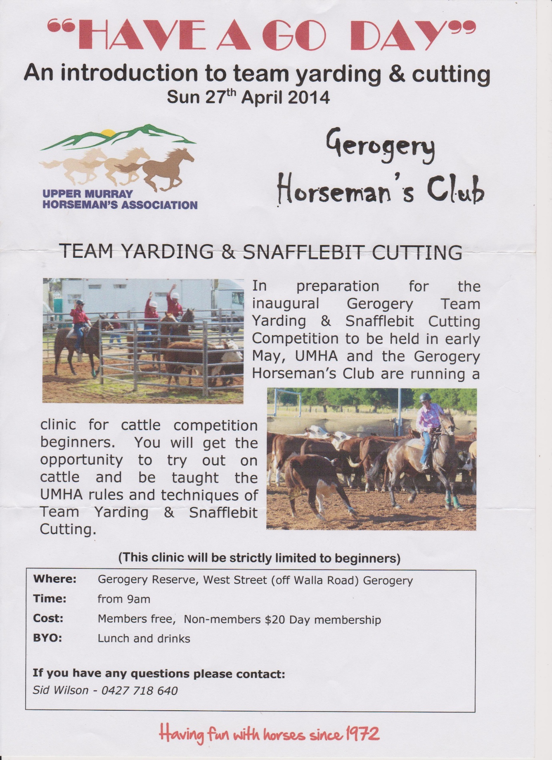

If you aren’t sure who Sid Wilson is……….. Ronnie Wilson.

Please note that we are not involved in the running of this event. Our grounds are being used but we have no responsibility or liability for this event.

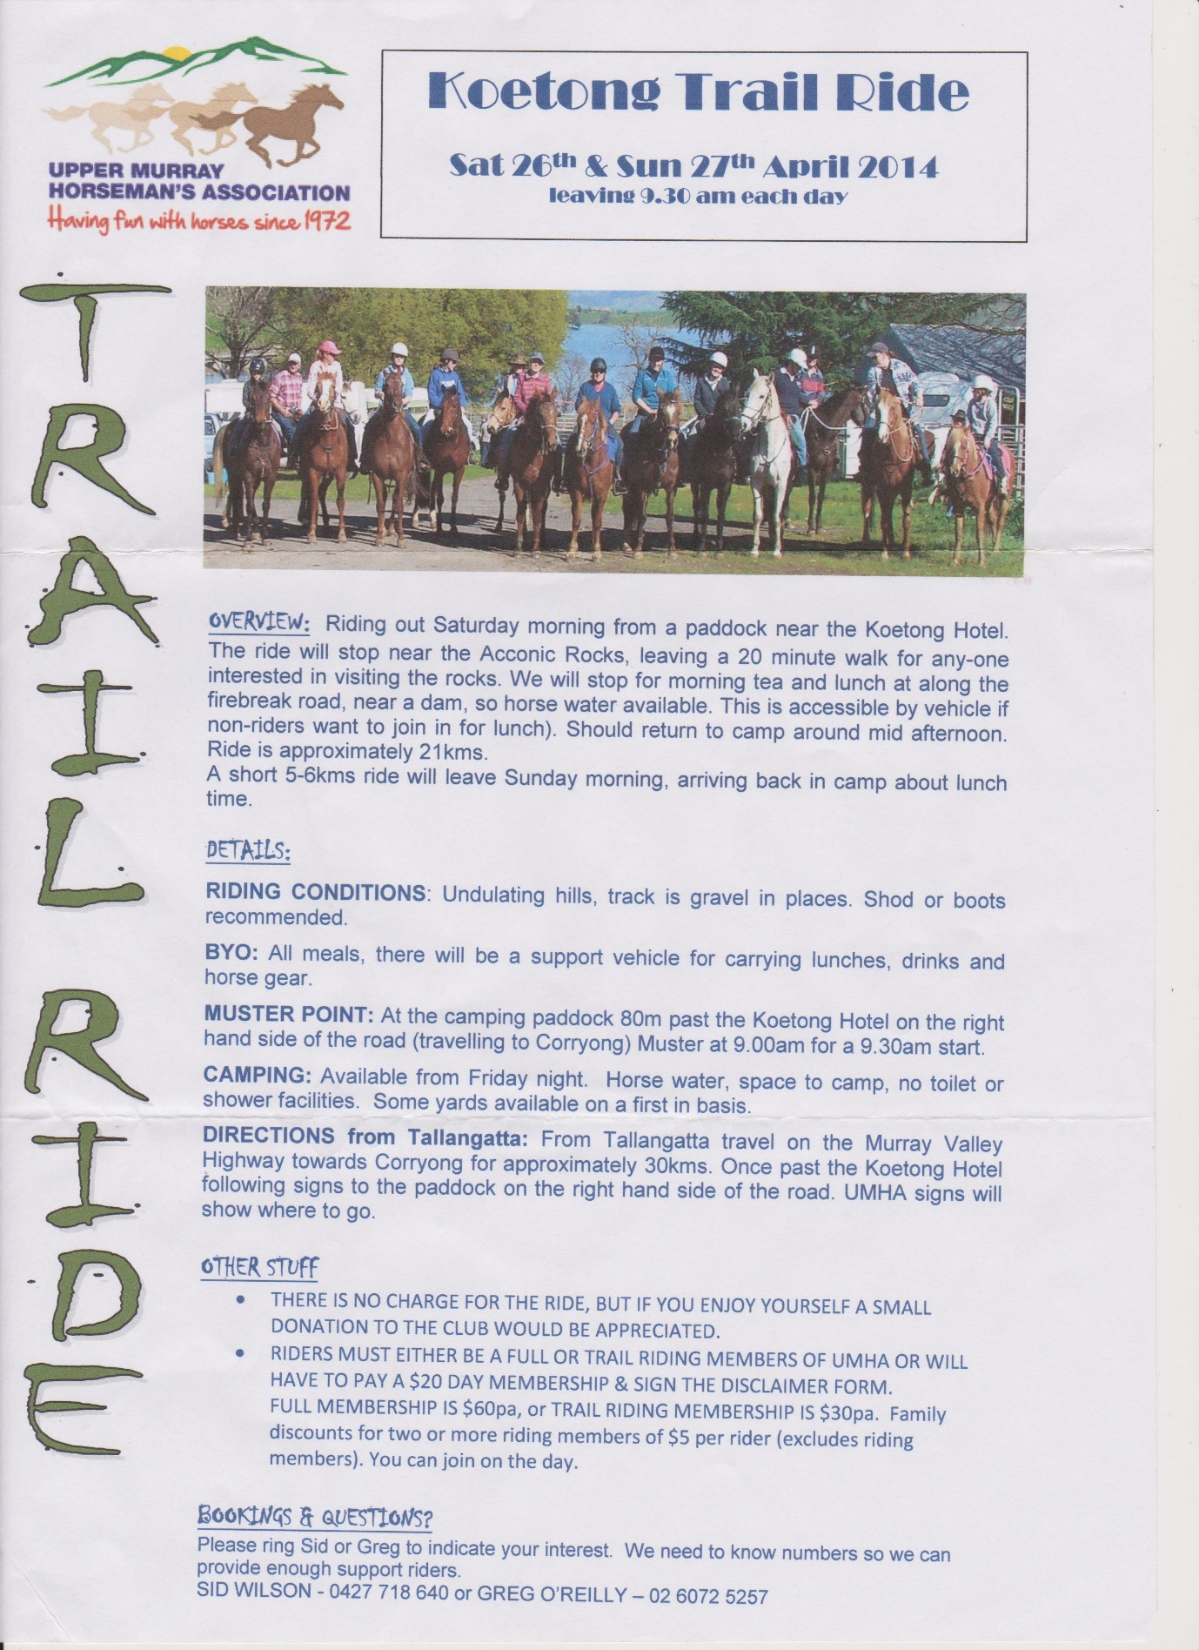

|  |  |  |  |  |  |  |
| --- | --- | --- | --- | --- | --- | --- |
| **April 2014** | | | | | | |
| **Sunday** | **Monday** | **Tuesday** | **Wednesday** | **Thursday** | **Friday** | **Saturday** |
|  |  | **1** | **2** | **3** | **4** | **5** |
| **6**Dressage (Official)  Bendigo and district ARC @Elmore | **7** | **8** | **9** | **10** | **11** | **12** |
| **13** CT and dressage jackpot (Official) Albury/Wodonga  ARC | **14** | **15** | **16** | **17** | **18** | **19** |
| **20** | **21** | **22** | **23** | **24** | **25** | **26**  Dressage & Show jumping weekend (Official) - Alpine ARC |
| **27** | **28** | **29** | **30** |  |  |  |

|  |  |  |  |  |  |  |
| --- | --- | --- | --- | --- | --- | --- |
| **May 2014** | | | | | | |
| **Sunday** | **Monday** | **Tuesday** | **Wednesday** | **Thursday** | **Friday** | **Saturday** |
|  |  |  |  | **1** | **2** | **3** |
| **4 Gerogery Horseman Dressage Jackpot**  Albury Equestrian Centre | **5** | **6** | **7** | **8** | **9** | **10** |
| **11** | **12** | **13** | **14** | **15** | **16** | **17**  TTT Horse Trials (Official)  Yarrambat ARC  Katrina McMasters Clinic at St Pauls |
| **18**  TTT Horse Trials (Official)  Yarrambat ARC | **19** | **20** | **21** | **22** | **23** | **24**  Social Rally at St Pauls  Dressage and jumps arenas available |
| **25** | **26** | **27** | **28** | **29** | **30** | **31** |

|  |  |  |  |  |  |  |
| --- | --- | --- | --- | --- | --- | --- |
| **June 2014** | | | | | | |
| **Sunday** | **Monday** | **Tuesday** | **Wednesday** | **Thursday** | **Friday** | **Saturday** |
| **1** | **2** | **3** | **4** | **5** | **6** | **7**  Navigation Ride (Official) Yackandandah ARC |
| **8**  Navigation Ride (Official) Wangaratta ARC | **9** | **10** | **11** | **12** | **13** | **14** |
| **15** | **16** | **17** | **18** | **19** | **20** | **21** |
| **22** | **23** | **24** | **25** | **26** | **27** | **28** |
| **29** | **30** |  |  |  |  |  |